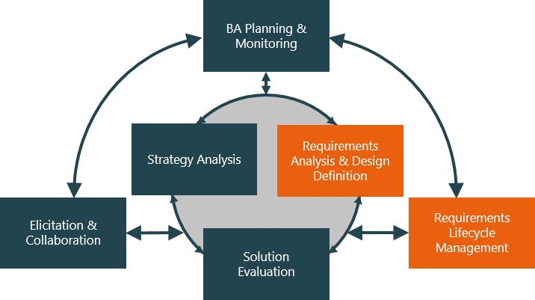

**Evaluate and communicate business requirements**

70309 Sang ah Park

|  |  |  |  |
| --- | --- | --- | --- |
| Name of Student | Sang ah Park | ID | 70309 |

# Assessment –

# Research & Questioning

Contents

Assessment – 1

Research & Questioning 1

***Instructions:*** 1

***Business Scenario*** 1

***Task 1: Determine support areas*** 2

***Task 2: Identify stakeholders*** 3

***Task 3: Develop support procedures*** 4

***Task 4: Assign Support Personnel*** 6

***Task 5: Short Answer Questions*** 6

***Task 6: Multiple Choice Questions*** 7

Index 12

#### View My Web Support:

<https://one-rainy-day.github.io/ECBR/>

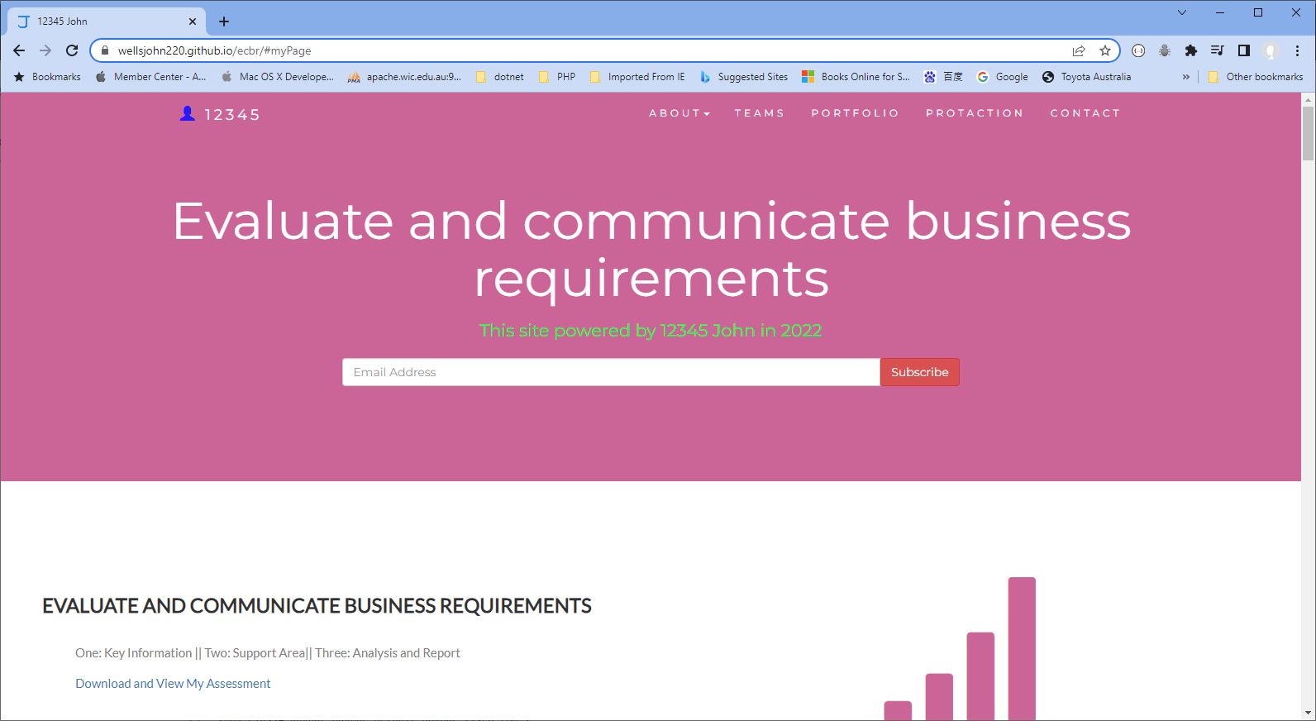

#### or

<https://wellsjohn220.wixsite.com/evaluate>

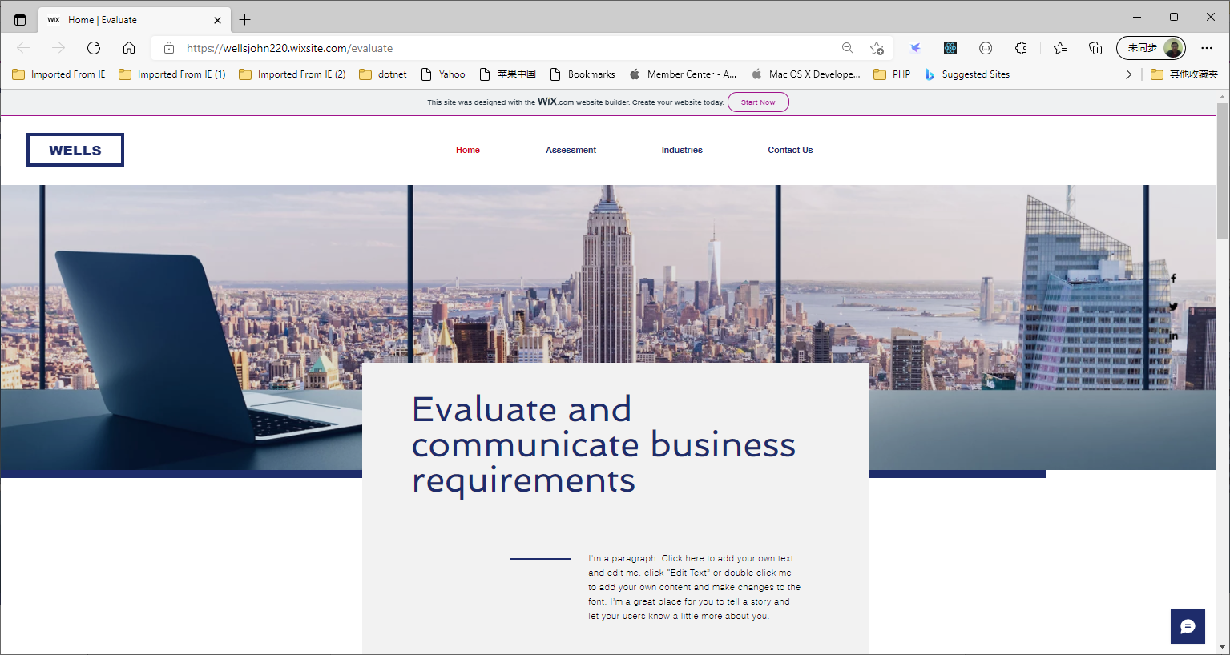

#### *Instructions:*

This assessment is to be completed individually. In this assessment you will be working through a number of written tasks based on case scenarios or research that relate directly to each element of competency for this cluster. Outlined below is information on how each of the tasks relates the element of competency covered.

Learn how to make Google Form: <https://www.youtube.com/watch?v=BtoOHhA3aPQ&t=4s>

Your tasks:

#### *Business Scenario*

D&K Books Pty Ltd is a bookstore owned by Mr. Dean Kerr. The business occupies two levels of an office building connected by escalators and lifts. D&K Books employs approximately six sales staff, one operation manager, two administrative officers, a bookkeeper and a marketing manager. They have an Ethernet network consisting of ten PCs (Intel I3 Desktop cloned), two switches, a router and three printers. They use the QuickBooks software to manage their entire business, including sales, inventory, ordering, accounts receivable, accounts payable, payroll and employee management. They also have two EFTPOS terminals one on each floor.

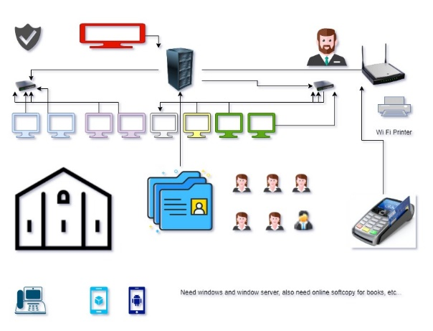

D&K Books has a Linux server that stores all of the data including the QuickBooks database. The server is backed up to tape regularly. They also have a website (hosted on an Australian ISP’s server, dynamic and static pages using asp.net) on which customers can browse the product catalogue and view current specials. They also lease a telephone system from Live Telecoms. The PABX (phone system) consists of a main switchboard and five remote phones with three incoming lines and a message-on-hold queue system.

Good network system, you need setup at least:

|  |  |
| --- | --- |
| Hard ware | Software |
| Server X 1 | Window Server |
| Computer X 8 | Windows |
| Printer X 1 | SQL server |
| Telephone X 8 | Virus Protection |
| Modern X 2 | MS office |
| Network Cable | Eftpos machine More… |

#### *http://imapwebsolutions.com/wp-content/uploads/2014/07/linux-dedicated-server.pngTask 1: Determine support areas*

Identify information technology (HW and SW) and list the technology in use in D&K Books and consider the following:

* What sort of support does the technology require?
* Who is likely to provide this support?
* Does the support arrangement already exist?

Present your answer in a table such as the one below:

|  |  |  |  |  |
| --- | --- | --- | --- | --- |
| **Technology** | **Description** | **Support Required** | **Provider** | **Support Already exists? (Yes/No)** |
| QuickBooks Software | ERP system that is designed to help business to manage the entire business cycle including sales, inventory, orders, accounts, and employment related problems. | Customisation, upgrades, training, user support | Various providers (such as Oracle and Gartner) are in market. | Yes |
| PC’s | Intel I3 Desktop cloned | Upgrade, repairs, customisation, networking |  | Yes (Assuming D&K Books obtained a warranty from the seller) |
| Server | Linux server | Accounts & permission management, security protection, backup and restore, upgrade, software installation |  | Yes (Assuming D&K Books obtained a warranty from the seller) |
| EFTPOS | Debit and credit card payments system | Accounts & permission management, upgrade, user support | Various providers (such as Suncorp, NAB, Commonwealth bank) are in market. | Yes |
| Telephone system | PABX is multiline telephone system typically used in business environments | Account, user support | Various providers (such as Telstra, Optus, Vodafone) are in market. | Yes |
| Website | Helping customers to access your products or services anywhere, anytime. | Web hosting, resource management, user support | Various providers (such as Telstra, Optus, Vodafone) are in market. | Yes |
| Network | wireless | No external | No | No |

Please review my website: [https://wellsjohn220.github.io/ecbr/#businesscase](https://wellsjohn220.github.io/ecbr/%23businesscase)

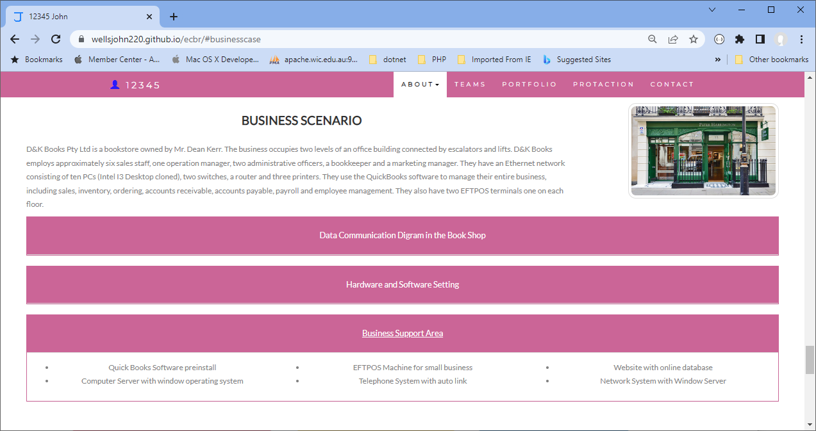

#### Stakeholder Analysis - Why You Need To Perform A Stakeholder Analysis?*Task 2: Identify stakeholders*

Identify stakeholders related in D&K Books system

All the staffs (the business owner, the relevant manager, the local workers and the remote workers) are stakeholders

comment:

* All the staff
* Customers
* Suppliers / Service providers

#### *Task 3: Develop support procedures*

1. Describe one positive and one negative experience you have had when seeking assistance from a telecommunication company, an ISP or a computer supplier. Your experience may be via telephone, email or even voice recognition.

|  |  |
| --- | --- |
| **Positive experience** | **Negative experience** |
| I had a problem with my computer. I called the service centre of the manufacturer and have my computer fixed next day. | We had a problem with the internet connection at work. One of my co-workers called the service centre of the service provider, and the operator was impatient and rude. |

1. Using the experiences described above please answer the following questions.



* 1. What support aspects were professional and/or unprofessional?
  2. How long did the support process take?
  3. Were the steps logical?
  4. Did they solve your problem?
  5. Was the call deflected to another area?

|  |  |  |
| --- | --- | --- |
|  | **Positive experience** | **Negative experience** |
| What support aspects were professional and/or unprofessional? | The service was immediate | The operator didn’t consider the level of knowledge of users. |
| How long did the support process take? | One day | 1 Week |
| Were the steps logical? | Yes | Yes and No (service matters) |
| Did they solve your problem? | Yes | We ended up change the router |
| Was the call deflected to another area? | No | No |

Using feedback form or Google survey form.

Here is the very simple survey demo:

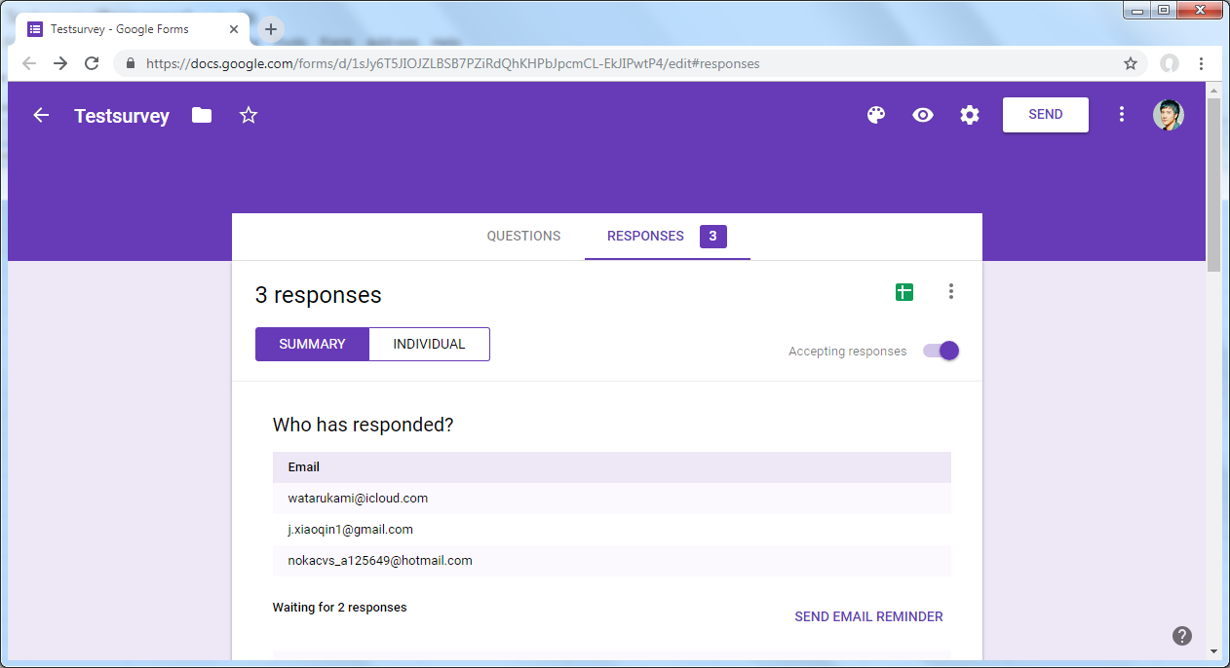

After I tested my friends, I could get nice response like:

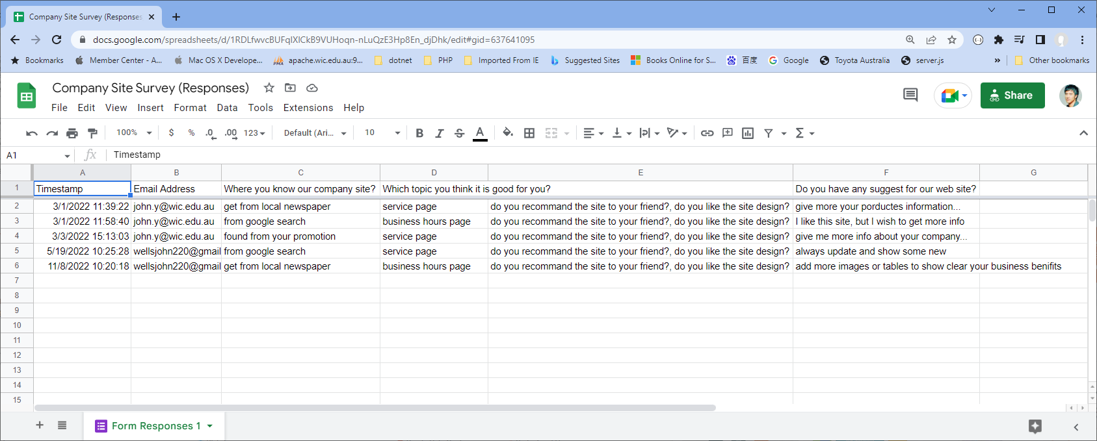

Or using link string:

https://docs.google.com/spreadsheets/d/1RDLfwvcBUFqlXlCkB9VUHoqn-nLuQzE3Hp8En_djDhk/edit#gid=637641095

Please review my website: [https://wellsjohn220.github.io/ecbr/#taskthree](https://wellsjohn220.github.io/ecbr/%23taskthree)

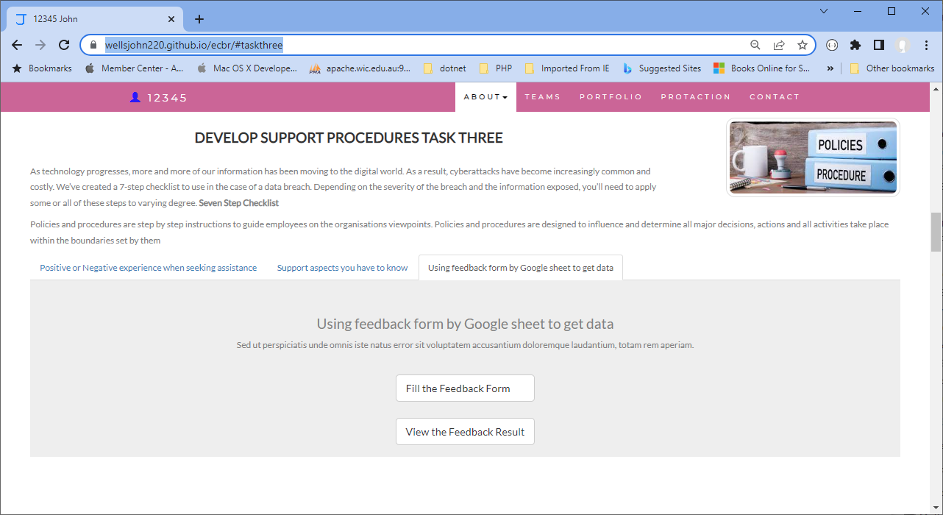

#### *Task 4: Assign Support Personnel*

Classify the following into soft skills and technical skills. Your answer should take the form of a table shown below.

|  |  |  |
| --- | --- | --- |
| **Skill** | **Soft skill** | **Technical skill** |
| A knowledge of Linux |  | O |
| The ability to work under pressure | O |  |
| The administration of Windows 2008 Server |  | O |
| The ability to formulate network and IT policies | O | O |
| The ability to write network documentation | O | O |
| The ability to give presentations | O |  |

Comment: Soft skills are not confined to one job and can benefit you in any workplace. Hard or technical skills are measurable abilities and knowledge that come through learning and can be job or task-specific. Where writing documentation and formulating policies require knowledge related to IT and network, they may also require critical thinking and communication skills.

Here is about document reequipment at support website: [https://wellsjohn220.github.io/ecbr/#document](https://wellsjohn220.github.io/ecbr/%23document)

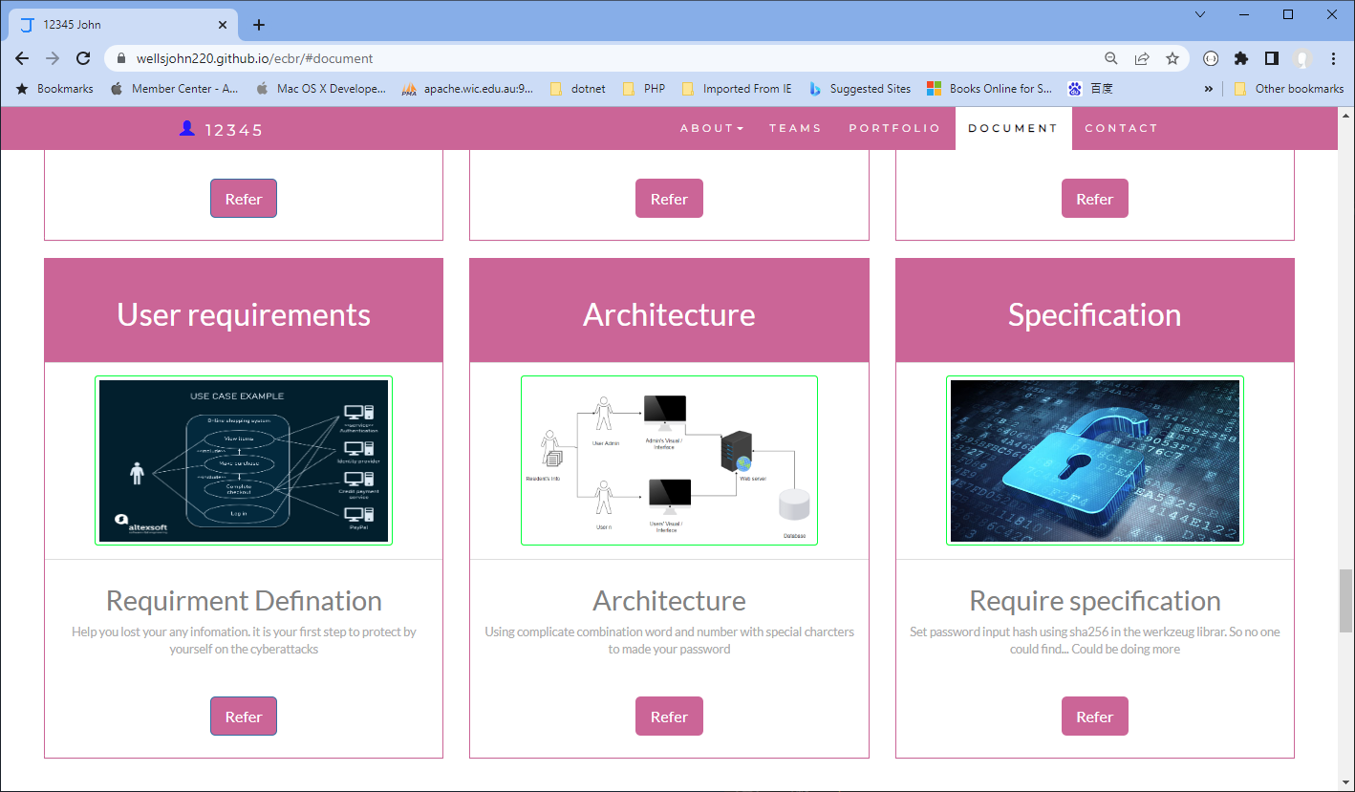

#### *Task 5: Short Answer Questions*

1. 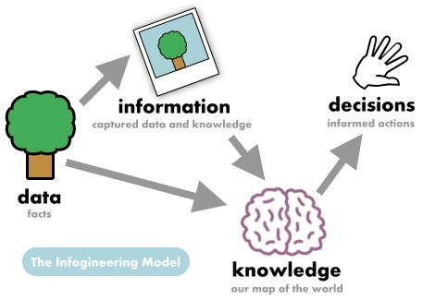Explain the relationship between data, information and knowledge.

* Data in their simplest form consist of raw alphanumeric values.
* Information is created when data are processed, organized, or structured to provide context and meaning. Information is essentially processed data.
* Knowledge is what we know.

1. What is quantitative data and how can you use it.

Quantitative data is data that can be counted or measured in numerical values. It is used when a researcher needs to quantify a problem, and answers questions like “what,” “how many,” and “how often.” This type of data is frequently used in math calculations, algorithms, or statistical analysis.

1. What is qualitative data and how can you use it.

Qualitative data is information that cannot be counted, measured or easily expressed using numbers. It is used to gain insights into people's feelings and thoughts and can be collected using questionnaires, interviews, or observation, and frequently appears in narrative form.

1. Give an example of how quantitative and qualitative data can be used in conjunction with each other

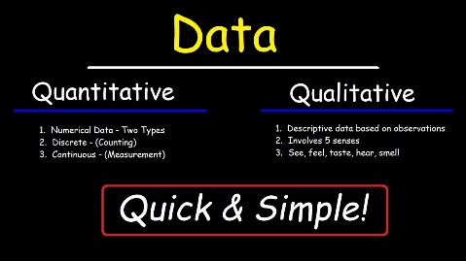Qualitative data may help researchers to map out survey instruments for use in a quantitative study or researchers can simply use the two types of data together to gain deeper insight into particular questions. For example, to gain information about the quality of life in certain areas, the researchers may refer to quantitative data, such as GDP, literacy rate, longevity rate etc. However, it is also reasonable to interview people living there or receive answers using questionnaires.

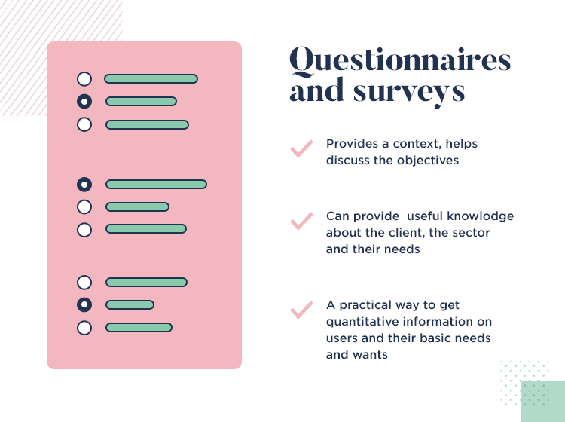

1. What sort of methods could you use to determine client requirements for a website design and key information sources?

* Customer questionnaires
* Customer interview
* Visual reference
* Proto typing

1. Give some examples of client requirements for a website design

* Colour Scheme
* Branding
* Navigation bar
* Sitemap

I made my web support page, could be accessed by: <https://one-rainy-day.github.io/ECBR>

#### *Task 6: Multiple Choice Questions*

1. Generally, how many points should a rating scale have?
   1. Five
   2. Four
   3. Ten
   4. Somewhere from 4 to 11 points

**Comment:** The psychometric literature suggests that having more scale points is better but there is a diminishing return after around 11 points.

**Reference:** <https://measuringu.com/three-points/>

1. What is the problem(s) with this set of response categories to the question “What is your current age?” o 1-5 o 5-10 o 10-20 o 20-30 o 30-40
   1. The categories are not mutually exclusive
   2. The categories are not exhaustive
   3. Both a and b are problems
   4. There is no problem with the above set of response categories

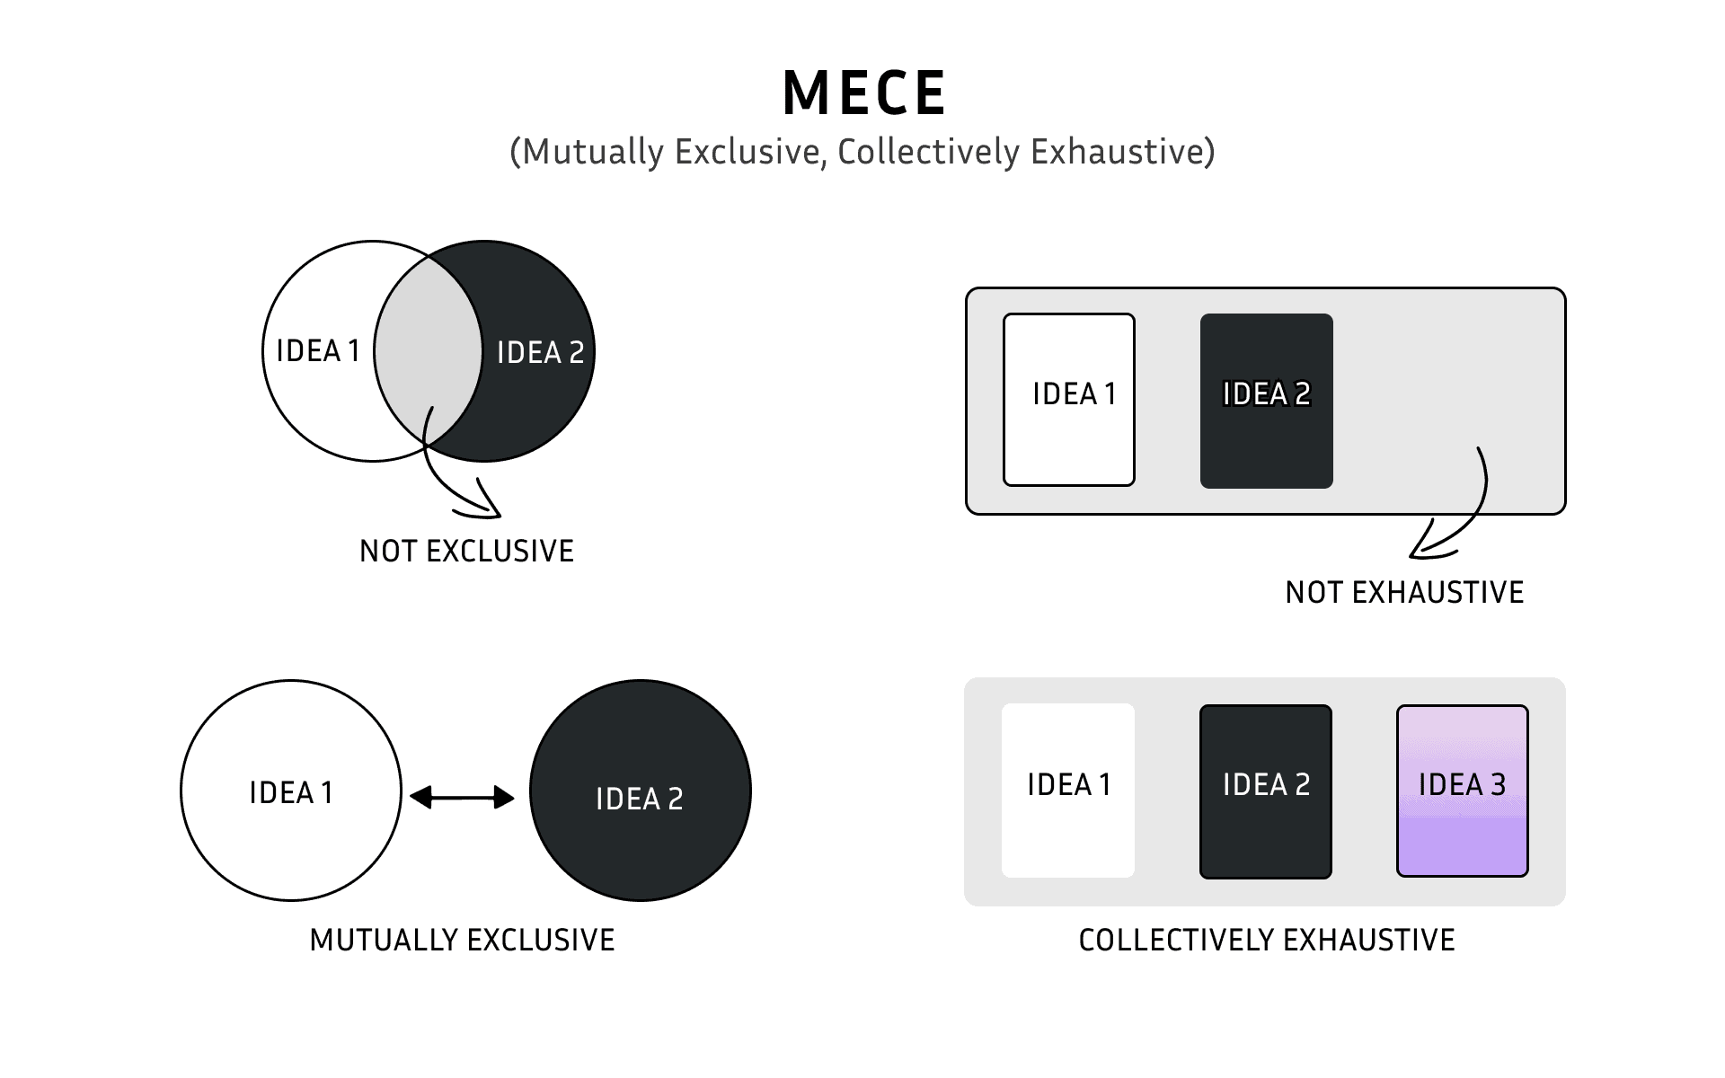

**Comment:** First, the categories (response options) must be mutually exclusive, which means they do not overlap with one another. Second, survey response options must be collectively exhaustive, meaning they provide all possible options that could comprise a response list.

**Reference:** <https://www.cvent.com/en/blog/events/survey-response-design-mutually-exclusive-collectively-exhaustive-categories>

1. You should mix methods in a way that provides complementary strengths and no overlapping weaknesses. This is known as the fundamental principle of mixed research.

a) True

b) False

**Comment:** mixed methods design reduces limitations in research.

**Reference:** https://studysites.sagepub.com/bjohnson4e/study/chapter.htm

1. According to the text, questionnaires can address events and characteristics taking place when?
   1. In the past (retrospective questions)
   2. In the present (current time questions)
   3. In the future (prospective questions)
   4. All of the above
2. Which of the following are principles of questionnaire construction?
   1. Consider using multiple methods when measuring abstract constructs
   2. Use multiple items to measure abstract constructs
   3. Avoid double-barrelled questions
   4. All of the above
   5. Only b and c

**Comment:** The goal of the questionnaire is to tap into and understand the opinions of participants about variables related to the research objectives. As constructing the questionnaire, researchers must constantly ask themselves if questions will provide clear data about what participants think or feel.

**Reference:** <http://www.analytictech.com/mb313/principl.htm>

1. Which of these is not a method of data collection?
   1. Questionnaires
   2. Interviews
   3. Experiments
   4. Observations

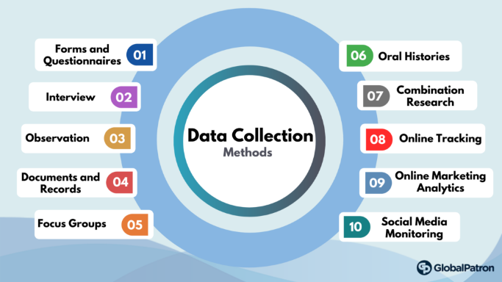

**Comment:** Understanding the variety of data collection methods available can help business decide which is best for their timeline, budget, and the question they’re aiming to answer. When stored together and combined, multiple data types collected through different methods can give an informed picture of their subjects and help the make better business decisions.

**Reference:** https://online.hbs.edu/blog/post/data-collection-methods

1. Secondary/existing data may include which of the following?
   1. Official documents
   2. Personal documents
   3. Archived research data
   4. All of the above

**Comment:** Existing data may be in the form of individual records (e.g., academic, medical, financial), data sets, interview notes, biospecimens, online profiles and posts (e.g., social media), and audio- or video-recordings.

**Reference:** https://campusirb.duke.edu/irb-policies/analysis-existing-data

1. An item that directs participants to different follow-up questions depending on their response is called a ____________.
   1. Response set
   2. Probe
   3. Semantic differential
   4. Contingency question

**Comment:** Questions that are limited to a subset of respondents for whom they are relevant are called "contingency questions."

**Reference:** https://methods.sagepub.com/reference/encyclopedia-of-survey-research-methods/n99.xml

1. Which of the following terms best describes data that were originally collected at an earlier time by a different person for a different purpose?

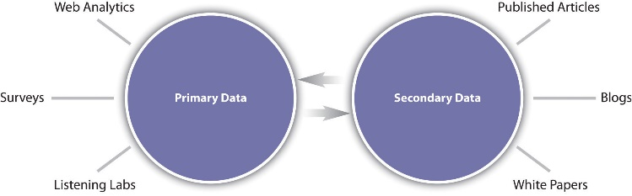a) Primary data

* 1. Secondary data
  2. Experimental data
  3. Field notes

**Comment:** Secondary data (also known as second-party data) refers to any dataset collected by any person other than the one using it.

**Reference:** https://researchguides.ben.edu/c.php?g=282050&p=4036581

1. Researchers use both open-ended and closed-ended questions to collect data. Which of the following statements is true?
   1. Open-ended questions directly provide quantitative data based on the researcher’s predetermined response categories
   2. Closed-ended questions provide quantitative data in the participant’s own words
   3. Open-ended questions provide qualitative data in the participant’s own words
   4. Closed-ended questions directly provide qualitative data in the participants’ own words

**Comment:** Open-ended questions are broad and can be answered in detail (e.g. "What do you think about this product?"), while closed-ended questions are narrow in focus and usually answered with a single word or a pick from limited multiple-choice options (e.g. "Are you satisfied with this product?" → Yes/No/Mostly/Not quite).

**Reference:** https://wp.stolaf.edu/iea/open-ended-versus-close-ended-questions/

1. Open-ended questions provide primarily ______ data.
   1. Confirmatory data
   2. Qualitative data
   3. Predictive data
   4. None of the above

**Comment:** open-ended questions are used in qualitative research and closed-ended questions are used in quantitative research.

**Reference:** <https://www.intotheminds.com/blog/en/qualitative-research-open-and-closed-ended-questions/>

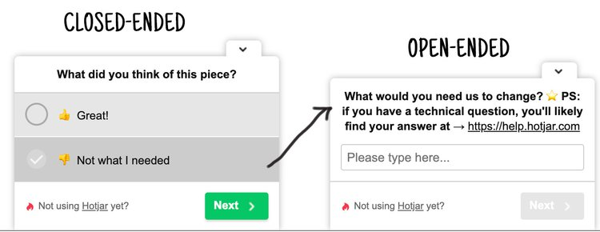

1. Which of the following is true concerning observation?
   1. It takes less time than self-report approaches
   2. It costs less money than self-report approaches
   3. It is often not possible to determine exactly why the people behave as they do
   4. All of the above

**Comment:** If an observer isn't skilled, is distracted, or is having their judgment influenced by outside factors, the insights gathered are of questionable value.

**Reference:** https://technologytherapy.com/understanding-data-pros-cons-observational-data/

1. Qualitative observation is usually done for exploratory purposes; it is also called ___________ observation.
   1. 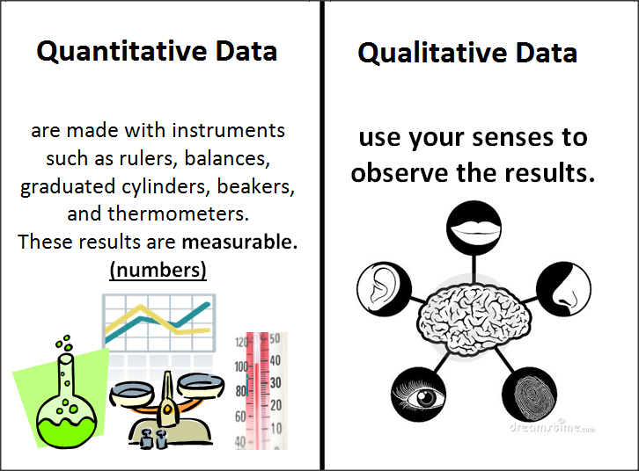Structured
   2. Naturalistic
   3. Complete
   4. Probed

**Comment:** Naturalistic observation is an observational method that involves observing people’s behaviour in the environment in which it typically occurs. Thus, naturalistic observation is a type of field research.

**Reference:** https://opentext.wsu.edu/carriecuttler/chapter/observational-research/

1. When constructing a questionnaire, it is important to do each of the following except ______.
   1. Use "leading" or "loaded" questions
   2. Use natural language
   3. Understand your research participants
   4. Pilot your test questionnaire

**Comment:** While a leading question prompts someone toward an answer, a loaded question is a trick question. No matter how a respondent answers, they're saying something that they may not agree with.

**Reference:** https://www.proprofssurvey.com/blog/leading-and-loaded-questions/

1. 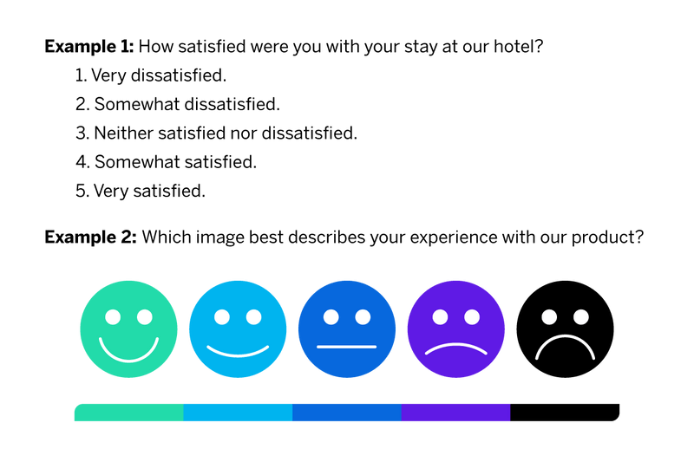Another name for a Likert Scale is a(n):
   1. Interview protocol
   2. Event sampling
   3. Summated rating scale
   4. Ranking

**Comment:** A Likert item is simply a statement that the respondent is asked to evaluate by giving it a quantitative value on any kind of subjective or objective dimension, with level of agreement/disagreement being the dimension most commonly used.

**Reference:** https://en.wikipedia.org/wiki/Likert_scale

1. Which of the following is not one of the six major methods of data collection that are used by educational researchers?
   1. Observation
   2. Interviews
   3. Questionnaires
   4. Checklists

**Reference:** https://www.jotform.com/data-collection-methods/

1. The type of interview in which the specific topics are decided in advance but the sequence and wording can be modified during the interview is called:

a) The interview guide approach

* 1. The informal conversational interview
  2. A closed quantitative interview
  3. The standardized open-ended interview

**Comment:** the guide approach is intended to ensure that the same general areas of information are collected from each interviewee; this provides more focus than the conversational approach, but still allows a degree of freedom and adaptability in getting information from the interviewee.

**Reference:** https://managementhelp.org/businessresearch/interviews.htm

1. Which one of the following in not a major method of data collection?
   1. Questionnaires
   2. Interviews
   3. Secondary data
   4. Focus groups
   5. All of the above are methods of data collection
2. A question during an interview such as “Why do you feel that way?” is known as

a) Probe

* 1. Filter question
  2. Response
  3. Pilot

**Comment:** Probing questions are follow-up responses to the listener’s answer to a previous question. Probing questions help speakers understand a listener's perspective, decipher their meaning and encourage more in-depth reasoning.

**Reference:** https://www.indeed.com/career-advice/career-development/types-of-questions

1. A census taker often collects data through which of the following?
   1. 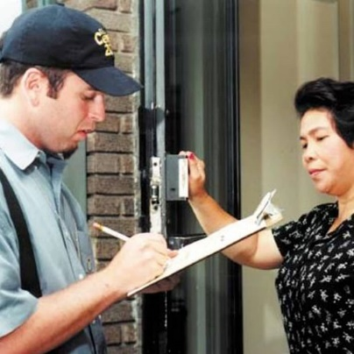Standardized tests
   2. Interviews
   3. Secondary data
   4. Observations

**Comment:** To complete the Census, the ABS contacts households in a few different ways. Letters and paper forms were delivered in some areas, and in other areas, visits were made to households

**Reference:** https://www.abs.gov.au/census/about-census/australian-census

1. The researcher has secretly placed him or herself (as a member) in the group that is being studied. This researcher may be which of the following?

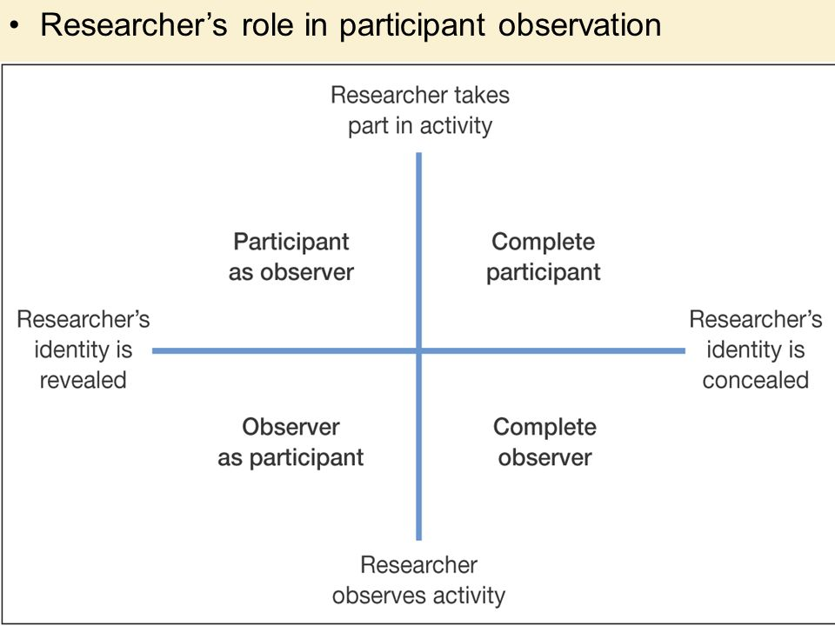a) A complete participant

* 1. An observer-as-participant
  2. A participant-as-observer
  3. None of the above

**Comment:** This is a fully embedded researcher, almost like a spy. Here the observer fully engages with the participants and partakes in their activities. Participants aren’t aware that observation and research is being conducted, even though they fully interact with the researcher.

**Reference:** https://measuringu.com/observation-role/#:~:text=Complete%20Participant,fully%20interact%20with%20the%20researcher.

1. Which of the following is not a major method of data collection?
   1. Questionnaires
   2. Focus groups
   3. Correlational method
   4. Secondary data
2. Which type of interview allows the questions to emerge from the immediate context or course of things?

a) Interview guide approach

* 1. Informal conversational interview
  2. Closed quantitative interview
  3. Standardized open-ended interview

**Comment:** As opposed to with a traditional question and answer interview, a conversational interview requires a different style of answering questions. Instead of practicing neatly wrapped up answers to potential questions, you will want to prepare conversational answers to the questions that could be asked.

**Reference:** https://aboutstaffing.com/conversational-interview

1. 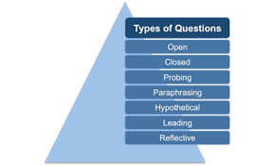When conducting an interview, asking "Anything else? What do you mean? Why do you feel that way?," etc, are all forms of:
   1. Contingency questions
   2. Probes
   3. Protocols
   4. Response categories

**Comment:** Probing questions are follow-up responses to the listener’s answer to a previous question. Probing questions help speakers understand a listener's perspective, decipher their meaning and encourage more in-depth reasoning.

**Reference:** https://www.indeed.com/career-advice/career-development/types-of-questions

1. When constructing a questionnaire, there are 15 principles to which you should adhere. Which of the following is not one of those principles?
   1. Do not use "leading" or "loaded" questions
   2. Avoid double-barrelled questions
   3. Avoid double negatives
   4. Avoid using multiple items to measure a single construct

**Comment:** Researchers should consider using multiple methods when measuring abstract constructs.

**Reference:** https://www.sagepub.com/sites/default/files/upm-binaries/26101_7.pdf

1. A customer-based Service Level Agreement structure includes:
   1. An SLA covering all Customer groups and all the services they use
   2. SLAs for each service that are Customer-focused and written in business language
   3. An SLA for each service type, covering all those Customer groups that use that Service
   4. An SLA with each individual Customer group, covering all of the services they use

**Comment:** A customer-based SLA is a contract with one customer, covering all the services used by this customer. Let's consider the relationship between you and your telecom operator. You use the voice services, SMS services, data services, and several other services of the telecom operator.

**Reference:** https://blog.masterofproject.com/3-types-sla/#:~:text=A%20customer%2Dbased%20SLA%20is,services%20of%20the%20telecom%20operator.

1. Which of the following best describes the goal of Service Level Management?
   1. To maintain and improve IT service quality in line with business requirements
   2. To provide IT services at the lowest possible cost by agreeing with Customers their minimum requirements for service availability and ensuring performance does not exceed these targets
   3. To provide the highest possible level of service to Customers and continuously improve on this through ensuring all services operate at maximum availability
   4. To ensure that IT delivers the same standard of service at the least cost

**Comment:** The purpose of Service Level Management is to ensure that all current and planned IT services are delivered to agreed achievable targets.

**Reference:** https://www.alaska.edu/files/oit/PinkSCAN_slm.pdf

1. The process to implement SLAs comprises of the following activities in sequence:
   1. Draft SLAs, catalogue services, review underpinning contracts and OLAs, draft SLRs, negotiate, agree

SLAs

* 1. Draft SLAs, review underpinning contracts and OLAs, negotiate, catalogue services,
  2. Review underpinning contracts and OLAs, draft SLAs, catalogue services, negotiate, agree SLAs
  3. Catalogue services, establish SLRs, review underpinning contracts and OLAs, negotiate service levels, agree SLAs

**Reference:** https://docs.bmc.com/docs/slm1808/stage-1-implementing-agreements-821937306.html

1. Which of the following is an example of a service level agreement (SLA) between an information systems support unit and a research unit in the laboratories of a large company?
   1. The maximum response time to get the system operational should it fail.
   2. The minimum ‘up-time’.
   3. The types of information that will be provided as standard.
   4. All of the above.

1. Some organisations bring a degree of formality to the internal customer concept by encouraging (or requiring) different parts of the operation to agree on:

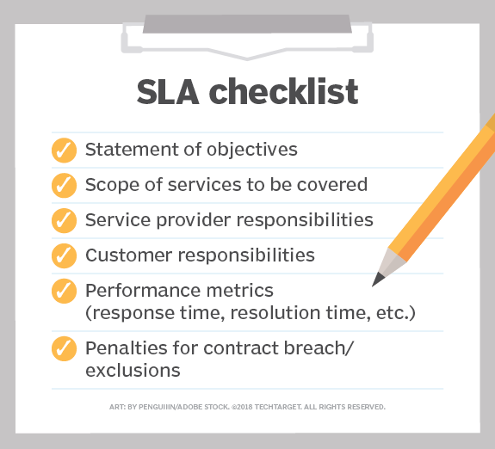a) Internal service agreements

* 1. Service level agreements
  2. Formal provision agreements
  3. Delivery agreements

**Comment:** SLAs commonly include many components, from a definition of services to the termination of agreement. Particular aspects of the service – quality, availability, responsibilities – are agreed between the service provider and the service user.

**Reference:** https://en.wikipedia.org/wiki/Service-level_agreement

## Index

B

bookstore 3

C

categories 11

closed-ended 12

D

data collection 14

L

Linux server 3

N

negative experience 6

network 3

O

open-ended 12

S

Service Level 14

service level agreement 15

service quality 14

soft skills 9

support 6

T

technology 4

telecommunications 6